# **Interaction Design Basics**

Interaction design focuses on creating engaging interfaces with well thought out behaviors. Understanding how users and technology communicate with each other is fundamental to this field. With this understanding, you can anticipate how someone might interact with the system, fix problems early, as well as invent new ways of doing things.

## Best Practices for Designing Interactions

Consider these qualities and associated questions when creating digital products that have an interactive element:

| **Questions to Consider when Designing for Interaction** | |
| --- | --- |
| **Define How Users Can Interact with the Interface** | * **What can a user do with their mouse, finger, or stylus to directly interact with the interface?** This includes pushing buttons, dragging and dropping across the interface, etc. * **What commands can a user give, that aren’t directly a part of the product, to interact with it?** An example of an “indirect manipulation” is when a user hits “Ctrl+C”, they expect to be able to copy a piece of content. |
| **Give Users Clues about Behavior before Actions are Taken** | * **What about the appearance (color, shape, size, etc) gives the user a clue about how it may function?** These help the user understand how it can be used. * **What information do you provide to let a user know what will happen before they perform an action?**These tell users what will happen if they decide to move forward with their action. This can include meaningful label on a button, instructions before a final submission, etc. |
| **Anticipate and Mitigate Errors** | * **Are there constraints put in place to help prevent errors?** The Poka-Yoke Principle says that placing these constraints forces the user to adjust behavior in order to move forward with their intended action. * **Do error messages provide a way for the user to correct the problem or explain why the error occurred?**Helpful error messages provide solutions and context. |
| **Consider System Feedback and Response Time** | * **What feedback does a user get once an action is performed?**When a user engages and performs an action, the system needs to respond to acknowledge the action and to let the user know what it is doing. * **How long between an action and a product’s response time?** Responsiveness (latency) can be characterized at four levels: immediate (less than 0.1 second), stammer (0.1-1 second), interruption (1-10 seconds), and disruption (more than 10 seconds). |
| **Strategically Think about Each Elements** | * **Are the interface elements a reasonable size to interact with?** Fitts’ Law says that [elements](https://www.usability.gov/how-to-and-tools/methods/user-interface-elements.html), such as buttons, need to be big enough for a user to be able to click it. This is particularly important in a mobile context that likely includes a touch component. * **Are edges and corners strategically being used to locate interactive elements like menus?** Fitts’ Law also states that since the edge provides a boundary that the mouse or finger cannot go beyond, it tends to be a good location for menus and buttons. * **Are you following standards?** Users have an understanding of how interface elements are supposed to function. You should only depart from the standards if a new way improves upon the old. |
| **Simplify for Learnability** | * **Is information chunked into seven (plus or minus two) items at a time?** George Miller found that people are only able to keep five to nine items in the short-term memory before they forgot or had errors. * **Is the user’s end simplified as much as possible?** Tesler’s Law of Conservation notes that you need to try to remove complexity as much as possible from the user and instead build the system to take it into account. With that said, he also notes to keep in mind that things can only be simplified to a certain point before they no longer function. * **Are familiar formats used?** Hick’s Law states that decision time is affected by how familiar a format is for a user to follow, how familiar they are with the choices, and the number |

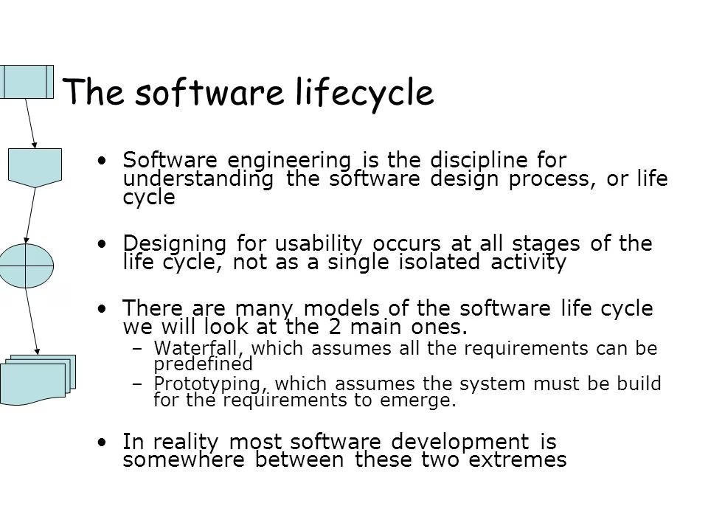**HCI in the process** 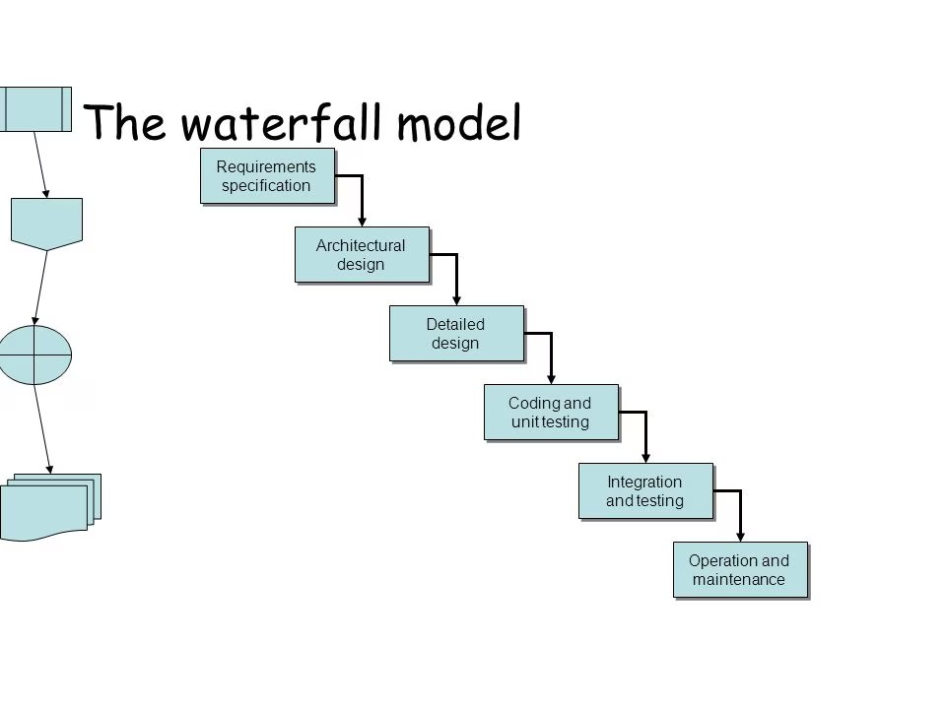

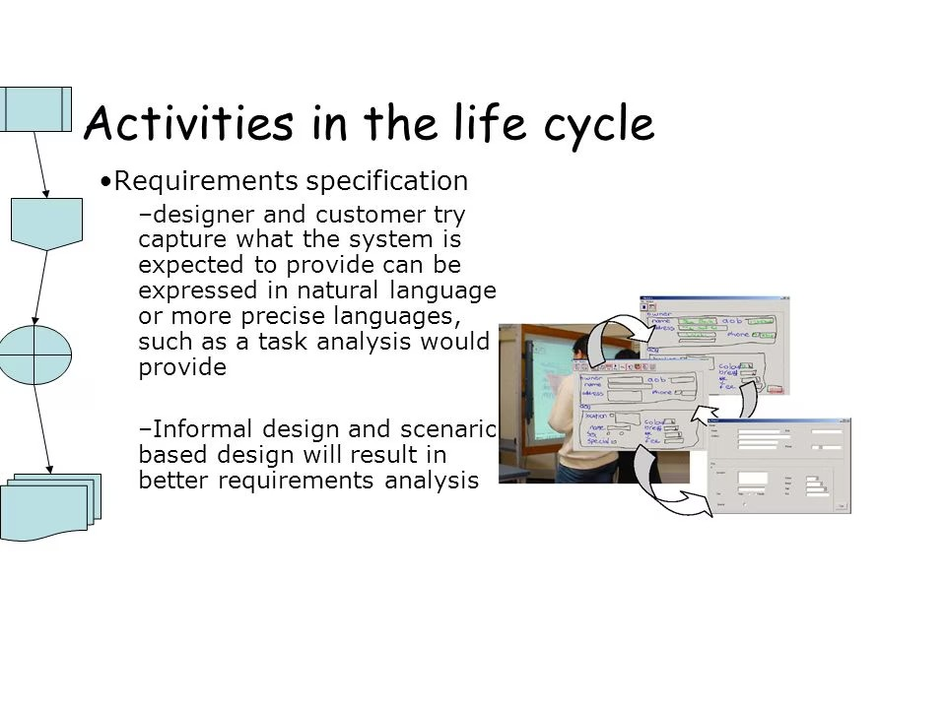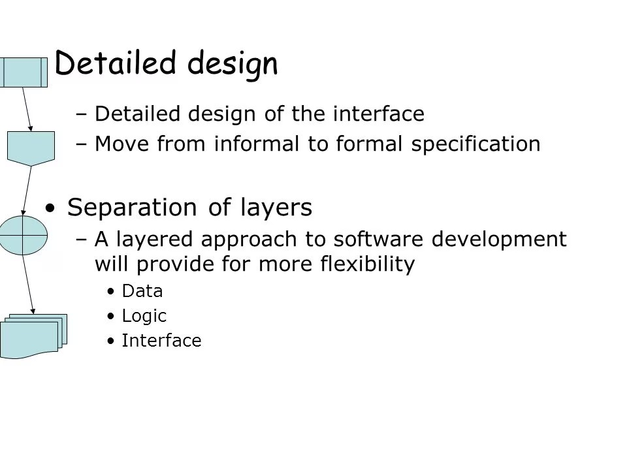

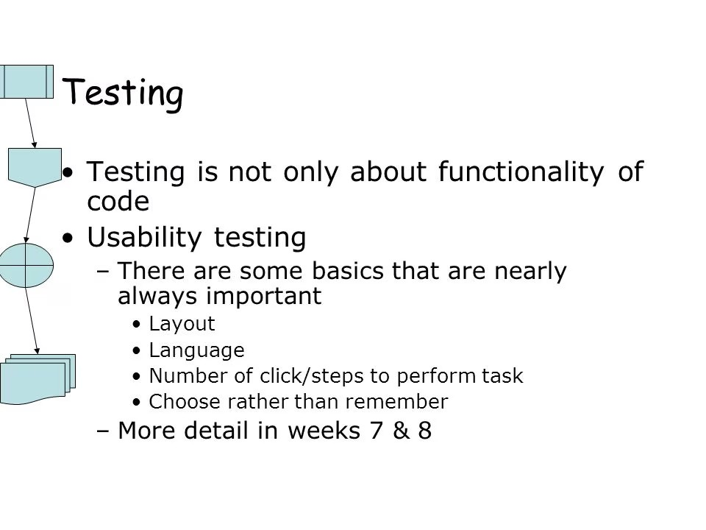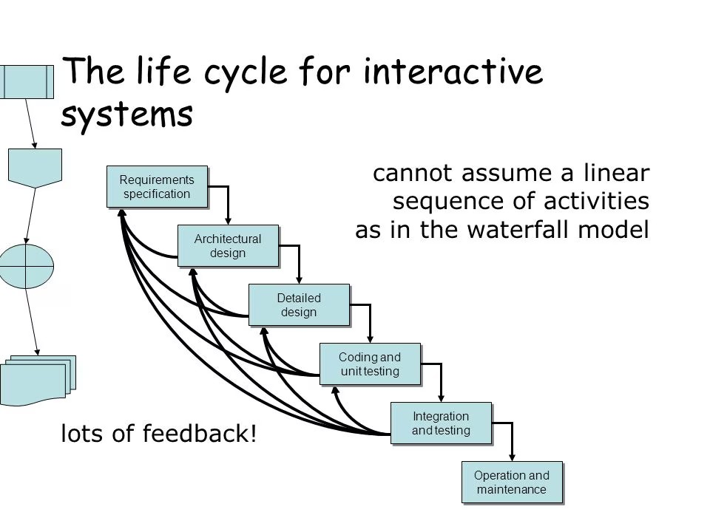

**Design Rules**

Understanding the principles of design and how they interact is vital for both new and expert designers. Implementing them purposefully is key to creating visually appealing, functional designs. While there’s plenty of debate over how many principles of design are out there (and even what they are), there are 12 that appear regularly on the list of principles. These 12 principles, explained in the infographic below, include contrast, balance, emphasis, proportion, hierarchy, repetition, rhythm, pattern, white space, movement, variety, and unity (there are also some additional Gestalt principles of design).

These principles are often talked about separately, but in practice, they work together to create a design that’s visually appealing and makes sense to the user. Expert designers understand how the principles support, reinforce, or even contrast with each other to create the desired effect.

Implementing the Principles of Design

Once a designer understands the basic design principles, they can more intentionally combine those principles to create designs that are aesthetically pleasing and functional.

For example, contrast can be used to create emphasis.

Principles of design: contrast and emphasis

Highlighting “reshape industries” in a contrasting color draws the reader’s eye to that particular bit of text, emphasizing it and setting it apart from the surrounding text.

Another way that emphasis can be achieved is through proportion.

Elements and principles of design: emphasis and proportion

Making “Problem Solvers, Idea Makers & Astronauts” significantly larger than other text on the page places the emphasis on that text.

Repetition can be used to create a sense of rhythm on the page. And that doesn’t always mean a regular or alternating rhythm. Repetition, when done intentionally, can be used to create a random rhythm.

Design fundamentals: repetition and rhythm

The repetitive shapes in the background of this site create a sense of random rhythm due to their varying sizes, colors, and placement.

White space doesn’t necessarily have to be completely white or free of pattern. In fact, subtle patterns can add visual interest to white space while still allowing it to function as a sort of visual “breathing space” within a design.

Basic design principles: white space and pattern

The subtle grid pattern in the background of this design adds some visual interest without being overwhelming to the eye.

Variety can help create a sense of movement in a design, depending on how it’s used.

Graphic design principles: variety and movement

The variety of shapes in this design and their fairly random layout create a sense of chaotic movement that leads the viewer’s eye to the center.

Repetition generally creates unity in a design without any extra effort on the part of the designer. But used intentionally, it can take that unity to a higher level.

Visual design principles: repetition and unity

Take the white backgrounds of the photos, consistent typography, and repeating image sizes and layout in this design. The repetition of common elements creates unity among various categories of products that might seem disjointed otherwise.

US-based full-time freelance UI designers wanted

Design Principles Don’t Exist in a Vacuum

Combining design principles isn’t just limited to two at a time. Most truly great designs combine at least half of these elements, and sometimes more.

Effectively combining multiple universal principles of design

This website uses a variety of principles: contrast between the hot pink and green; repetition in the patterns being used and consistent shoes, haircut, and sunglasses; unity among the various outfits (which is further reinforced by the repeating patterns); and variety in the styles of outfits. It’s a strong design statement that follows multiple principles to create a visually appealing and eye-catching website.

Combining multiple design rules

Here’s another example of a design that uses multiple principles effectively. The large header creates emphasis on that particular text, while the smaller type appears less important due to proportion. The shapes in the background create a sense of random rhythm and movement, while the similar color scheme between them creates unity. Stronger and larger shapes on the right balance the text and white space on the left.

Some designers follow these principles without even realizing they’re doing it. Other times, a designer can’t quite put their finger on why a design isn’t working, but when they consult these principles they can often find the solution.

Understanding the principles of design and how they interact with one another is of paramount importance for both new and expert designers alike. Implementing them purposefully and intentionally in design projects is key to creating visually appealing and functional designs.

**Implementation Support**

Implementation Support services help customers enhance existing functionalities through technological support resources.  Increase successful outcomes across people, processes and technology and get the support you need to implement a project effectively with Momentum, Inc.

## **WHAT IS IMPLEMENTATION SUPPORT?**

Implementation Support is a planned approach to integrate new or upgraded software or systems into the existing workflow of an organizational structure to help ensure the success of a business’ overall system.  Successful implementation projects require precise execution of planned tasks by resources dedicated to ensuring that project outcomes meet established success criteria. Momentum’s team of implementation support consultants work closely with your business to ensure you get the most out of your IT solutions, offering system implementation solutions, resources and training. With our suite of services, ranging from ensuring the quality of a software application through testing activities, your business gets the support it needs to evolve and succeed in the face of advancing technology.

* Programming tools for interactive systems provide a means of effectively translating abstract designs and usability principles into an executable form. These tools provide different levels of services for the programmer.
* Windowing systems are a central environment for both the programmer and user of an interactive system, allowing a single workstation to support separate user-system threads of action simultaneously.
* Interaction toolkits abstract away from the physical separation of input and output devices, allowing the programmer to describe behaviors of objects at a level similar to how the user perceives them.
* User interface management systems are the final level of programming support tools, allowing the designer and programmer to control the relationship between the presentation objects of a toolkit with their functional semantics in the actual application.